CS 5890 Assignment 5: Graph Attention Networks

- A GAT was trained on the CORA citation network, based on the architecture published by Aleksa Gordić on their Github. Adding a 3rd layer simply required changing the parameters where the model is constructed. The additional layer used 8 attention heads, and computed 8 features. The updated configuration is as follows:

gat_config = {
"num_of_layers": 3,
"num_heads_per_layer": [8, 8, 1],
"num_features_per_layer": [CORA_NUM_INPUT_FEATURES, 8, 8, CORA_NUM_CLASSES],
"add_skip_connection": False,
"bias": True,
"dropout": 0.6,
}

On the original train/test split, this architecture resulted in an accuracy of 79%. This is slightly lower than the original model’s 82.9%. This could indicate more overfitting due to the increased parameter count, but some hyperparameter optimization should be done before making conclusions.

The TSNE embedding of the nodes according to our new model is:

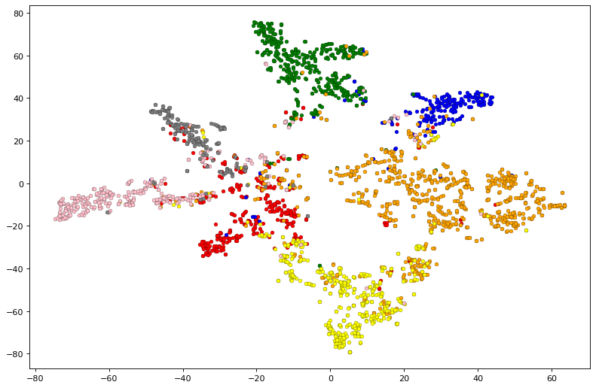
2. The model was evaluated with multiple train/validation/test splits to better understand its accuracy. This was done by modifying the constants that control the split, as follows (the index for train_ending_indices varied between splits):

train_ending_indices = [199, 399, 599, 799, 999]
CORA_TRAIN_RANGE = [0, train_ending_indices[0]]
CORA_VAL_RANGE = [1000, 1499]
CORA_TEST_RANGE = [1500, 2499]
CORA_NUM_INPUT_FEATURES = 1433
CORA_NUM_CLASSES = 7

The following train/test splits were evaluated:

Training Indices | Validation Indices | Test Indices | Accuracy
0:199 | 1000:1499 | 1500:2499 | 83.9%
0:399 | 1000:1499 | 1500:2499 | 86.2%
0:599 | 1000:1499 | 1500:2499 | 84.3%
0:799 | 1000:1499 | 1500:2499 | 84.4%
0:999 | 1000:1499 | 1500:2499 | 83.8%

